Instructors
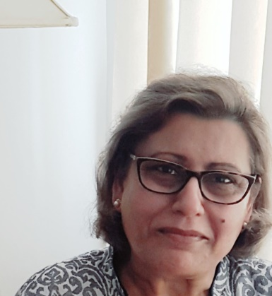
Dr. Aisha Y Malik

MBBS, M.Phil.(Haem.), D.Phil.(Oxon.) AFHEA
Tutor, Dept. of Philosophy, Oxford Lifelong Learning. University of Oxford; Associate Sn. Tutor, Warwick Med. School, University of Warwick.

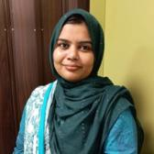

Dr. Annum Ishtiaq
MBBS, FCPS, DHEP, Palliative Medicine Fellowship (AKU)
Palliative Care Physician
Sultan Qaboos Comprehensive Cancer Center and Research Center

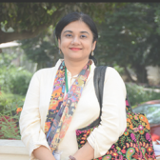

Ms. Asfiya Aziz
Mass Communication, MBeth
Additional Director Communications, Managing Editor Publications, Jinnah Sindh Medical University, Karachi, Pakistan
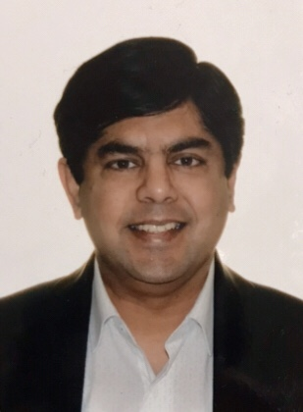

Mr. Faisal Shafiq
MBA, MBE
Senior Project Manager, Alberta Health
Services Edmonton, Alberta, Canada
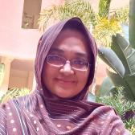

Dr. Faiza Ahmed
MPhil Biochemistry, Certificate in Medical Teaching, MBeth, MBBS
Senior lecturer, Department of Biochemistry CMH Lahore Medical College and Institute of Dentistry, Lahore
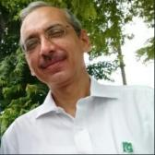

Dr. Jamshed Akhter
FCPS, FRCS, FACS, MBeth, MHPE, PGD Biomedical ethics
Visiting Professor, Department of Pediatric Surgery, National Institute of Child Health, Karachi Pakistan
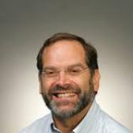

Professor John Lantos
MD
President JDL Consulting, New York City, USA
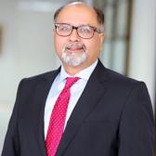

Professor Dr. M. Zahid Bashir
Principal, Shalamar Medical & Dental College, Lahore.
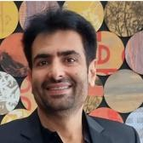

Dr. Mustafa Aslam
DMJ, MBeth, CPB
Section Head Forensic Medicine, Faculty of Health Sciences, Aga Khan University, Karachi, Pakistan
Director - Health and Human Rights Course, Masters of Bioethics Program, Aga Khan University
Governor- World Association of Medical Law
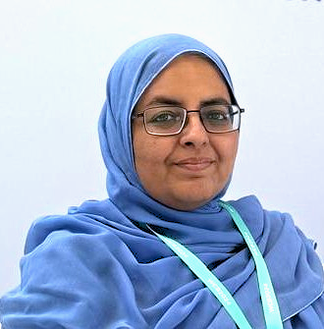

Dr. Nida Ilyas Shamsi
MBBS, FCPS, MHPE, FRCGP(INT)
Clinical Head - Karachi, Family Medicine & Community Health
Clinical Head - South, Primary Care Program
Indus Hospital & Health Network



Dr. Nuzhat Irfan Malik
M.B.B.S, MCPS, MHPE, DHEP
Radiologist, Past Chair CEC, Indus Hospital & Health Network
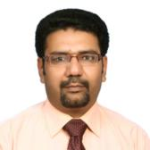

Dr.Raja Sajjad Asghar
M.B.B.S, MPH, M.Phil, DHEP
Director Organ Procurement Cell, Punjab Human Organ Transplantation Authority
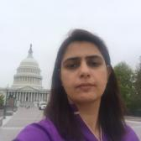

Dr. Sarosh Saleem
MBBS, MBeth, FPB, PhD (Health Care Ethics) Co-Director, Diploma in Healthcare Ethics & Professionalism
Assistant Professor & Head, Bioethics Department
Chair, Hospital Ethics Committee, Shalamar Hospital
Head, Bioethics Unit, Int’l Chair in Bioethics/WMA Cooperation Center
Shalamar Medical & Dental College, Lahore, Pakistan
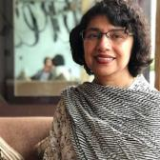

Dr. Shaper Mirza
Associate Professor at the Department of Life Sciences
Doctorate, The University of Alabama at Birmingham (UAB)
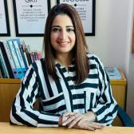

Sumaira Khowaja-Punjwani
PhD (USA), CPB (USA), MBeth (Pak) & BSCN (Pak)
Director Undergraduate Program & Associate
Professor, Faculty of Nursing and Midwifery Ziauddin University, Karachi Pakistan
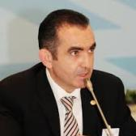

Prof. Dr. Vugar Mammadov
MD
Professor of Forensic Medicine, Azerbaijan Medical University.
Professor of FM, Medical Law and Bioethics, Law Faculty, Baku State University
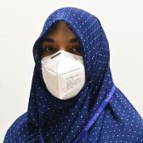

Dr. Unaisa Kazi
MCPS/DCH, DHEP
Specialist Pediatric, Emergency Department, Indus Hospital and Health Network (IHHN)
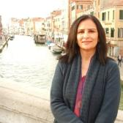

Maj. Dr. Saadia Shehzad
MBA, MPH, MPhil, MME, DHEP
Prof & HOD, Community Medicine
Queens Medical College Kasur, Pakistan
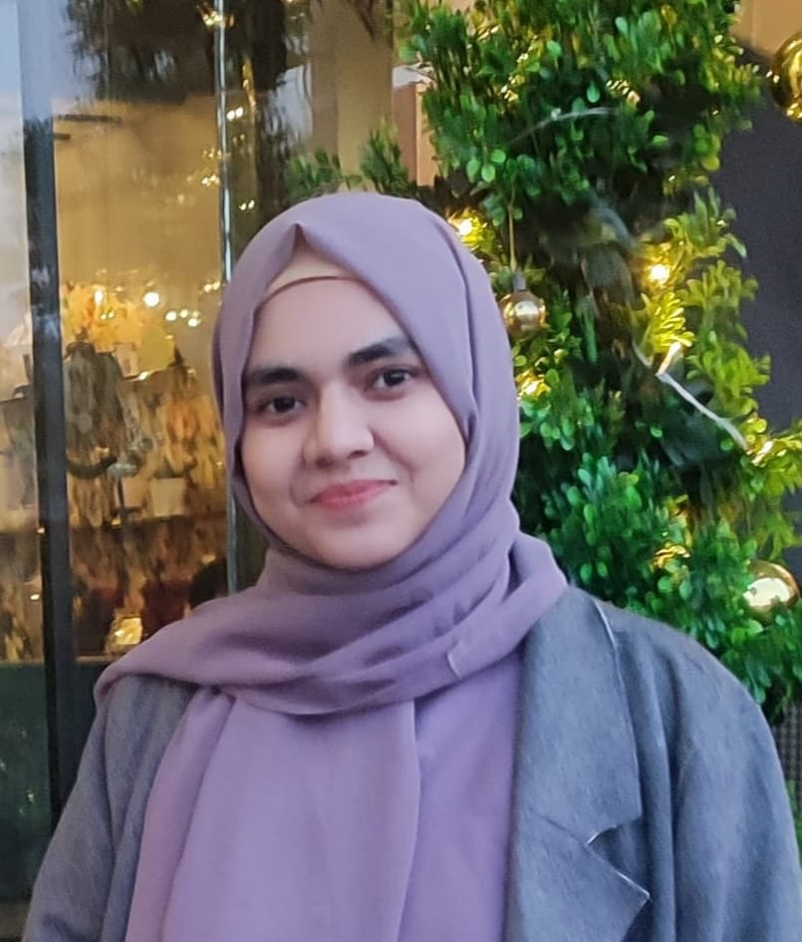

Amna Farooq
MA Applied Islamic Ethics, Islamic Bioethics HBKUx
Research Center for Islamic Legislation and Ethics (CILE) , Hamad Bin Khalifa University Qatar.
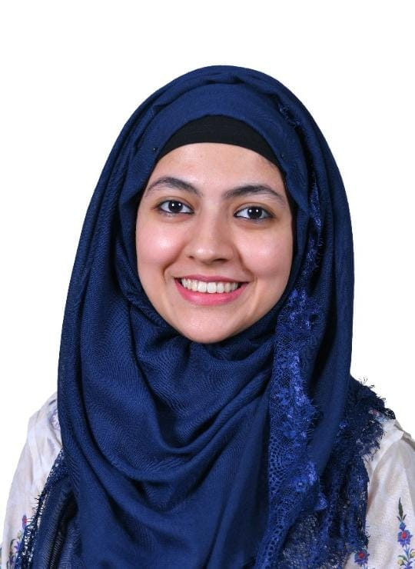
Dr. Farwa Ayub
MBBS, MBeth
Senior Demonstrator, Shalamar Medical and Dental College, Lahore, Pakistan

